Custom Lab Project:

Alarm Clock Design

Annie Du (861214887)

adu003@ucr.edu

1. Introduction

The objective of this custom lab project was to put the knowledge and techniques learned in class and create a unique embedded system. However, because this project was created during a short amount of time, we were giving predetermined projects to choose from – from which I decided to choose the Alarm Clock Design.

1. Design

The main aspects of this design are as follows:

LCD to display current time.

Button press to set current time.

Button press to set alarm.

Increment Time with button press.

Buzzer goes off for alarm.

Button for snooze function.

Button to stop alarm.

Visual cue for hearing impaired users.

1. Implementation and Concepts
   1. Timer / Different Period Tasks

The timer was used to count each ticking second so that the clock will be able to accurately increment one second at a time. I used a counter to allow tasks to occur in a different period so that button input is more comfortable and would not need to be held down for at least one second to increment the time during the setting state. This prevents button inputs from overlapping into different state machines while still being able to hold the button to increment the time.

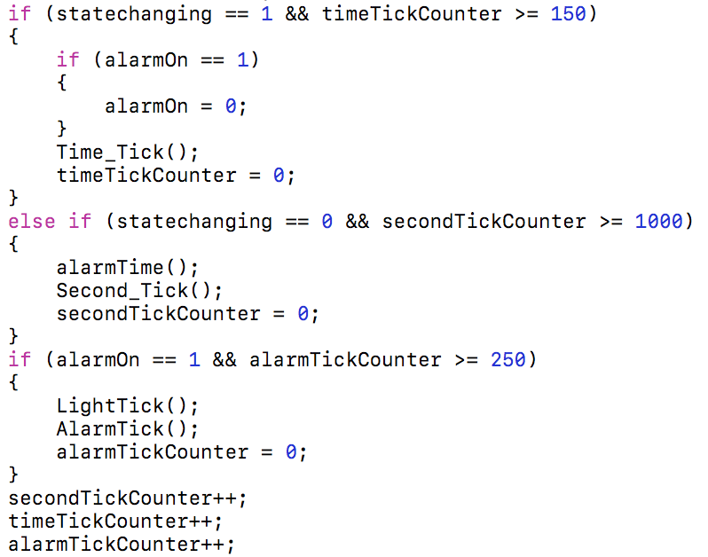

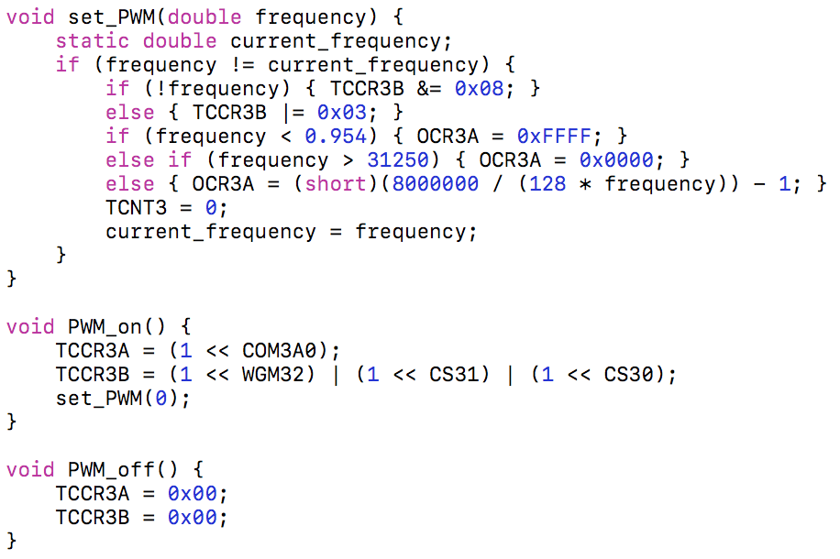

* 1. Pulse Width Modulation

In order for the speaker to work as a buzzer, I decided to use the pulse width modulator to allow a certain frequency to be played on the speaker. It is currently set to 261.63 as an arbitrary tone and buzzes once every 250ms to act as an alarm.

* 1. Lookup Tables

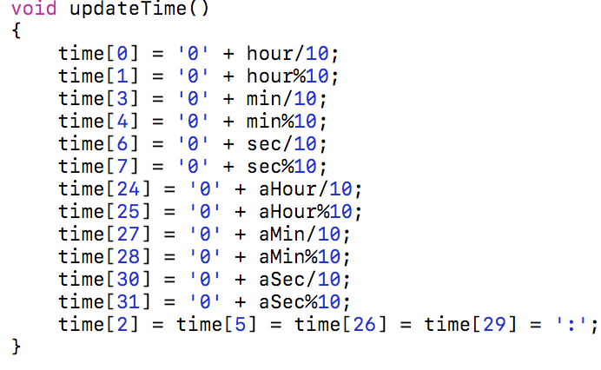I used lookup tables for certain pieces of data. For example, I had an array of binary numbers that represented the output pattern for the LEDs. This allowed me to reduce the number of states in my blinking state machine by addressing a location in the array rather than creating a state for each LED. I also created a lookup table for the LCD Display in order to change the data on the display by looking up the position of a certain piece of data, and updating it via a helper function I had named updateTime().

1. Conclusion

Overall, I think I was able to display my knowledge of the course with this custom lab project. I was able to create an alarm clock that was, to my knowledge, as accurate as most alarm clocks out in the market today with the materials that were available to me. I was also able to optimize my design using the various techniques taught in class to ensure a more realistic design. Some problems that occurred during the process of the creation included some hardware malfunction as my power supply had burned out, but it was quickly fixed with a temporary 5V solution until a new power supply was purchased.